**Worksheet 14 – GUIs**

1. Create a GUI program as shown below, in which the user can press a button so that the system generates a random number from 1 to 99 and displays it in password format. The user tries to guess the number. When entering a guess, he is told whether he should try lower or try higher, and a “you win” message should be shown when the number is guessed.

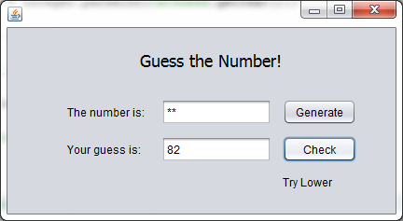

**Note: You need to use Global variables for this program. These are variables declared inside the class definition, but not inside a method. The variable scope is all methods of that class!**

1. Create a GUI program as shown below, in which the user can click on the *Count* button and the counter increases with each click.

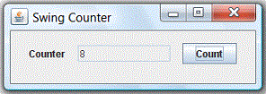

1. Create a GUI program as shown below, in which the user can choose a lunar phase from a combo-box and an image of that phase appears.

The lunar phases are as follows: *New, Waxing Crescent, First Quarter, Waxing Gibbous, Full, Waning Gibbous, Third Quarter, Waning Crescent.*

An image for each phase will be provided.

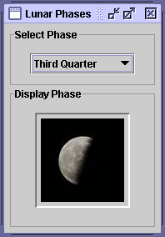

Hint: In order to display the images, use a label (resized accordingly). Then use the following example code to change its icon during execution:

ImageIcon icon = new ImageIcon("images//image0.jpg");

jLabel1.setIcon(icon);

(The example assumes that the images are saved in a folder called “images” in the project’s root folder.

1. Copy the program in Question 3) and modify it such that the phases are shown in a JList instead.